16th July 2021
Heyford Park School
Primary Newsletter
Dear Families
Newsletter
As we approach the final days of the academic year we can reflect on what has been a challenging but successful year. As a community we have needed to work together even more than usual with a lockdown during the Spring Term and Covid guidance to follow. We would like to thank you for your role in this as everyone has had a part to play and we appreciate that this has been a difficult time for parents and carers. Even though the Covid guidance is due to change on Monday, we are not planning on making any changes for the last two and a half days of the year. At present we are planning if there will be any changes in September due to guidance changing, this is likely to involve the staggered start and finish but will let you know once confirmed. I will be writing a final newsletter on Wednesday.

DREAM ON!
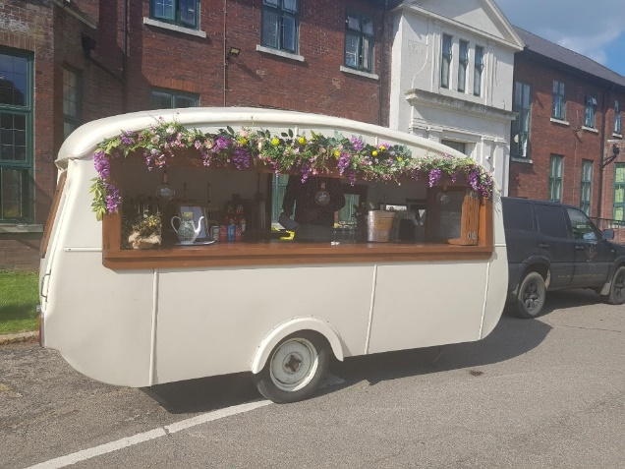
The Year Six made us all incredibly proud with their production of Dream On – an adaptation of Shakespeare’s Midsummer Night’s Dream. Their commitment, enthusiasm and creativity to deliver lines and produce a fantastic play was admirable. I would like to personally thank the staff who went above and beyond for the children and the parents - thank you Mrs Evans, Mrs Osbourne, Mrs Jones, Mrs Mellor and Steph Woodman. The intimate audience were treated with refreshments and sunshine as the children entertained them! If there are any parents that would like to buy a DVD please make sure that you order using ParentPay by 10am on Monday 19th July.

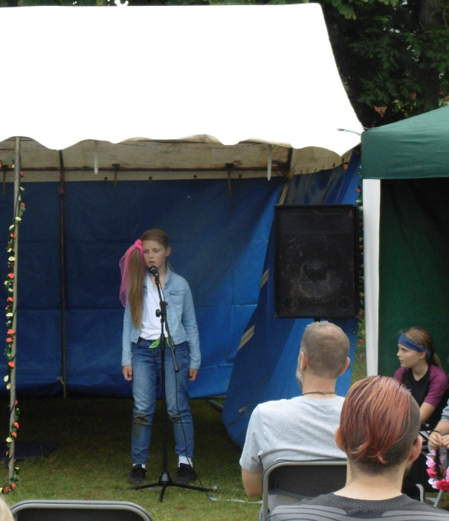

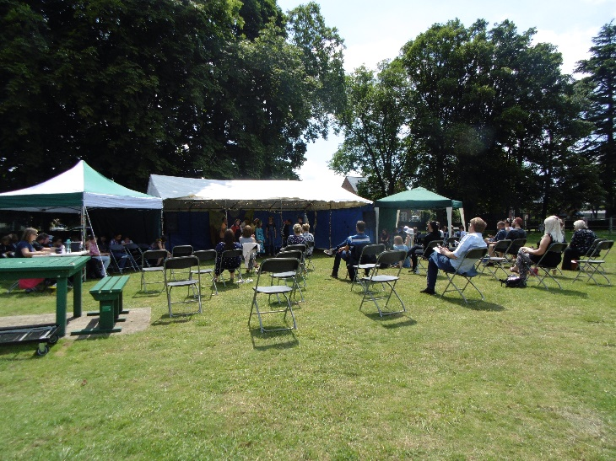

A DAY OF OLYMPICS FOR YEAR 3
Year 3 spent the day on Thursday learning about the Olympic and Paralympic Games. We looked at the range of sports that are part of the Games, and learnt more about the game of Boccia. We then looked at symbols of the games, made some medals and designed our own mascots for Team GB, the Olympic and Paralympic Games, some of which can be seen below!
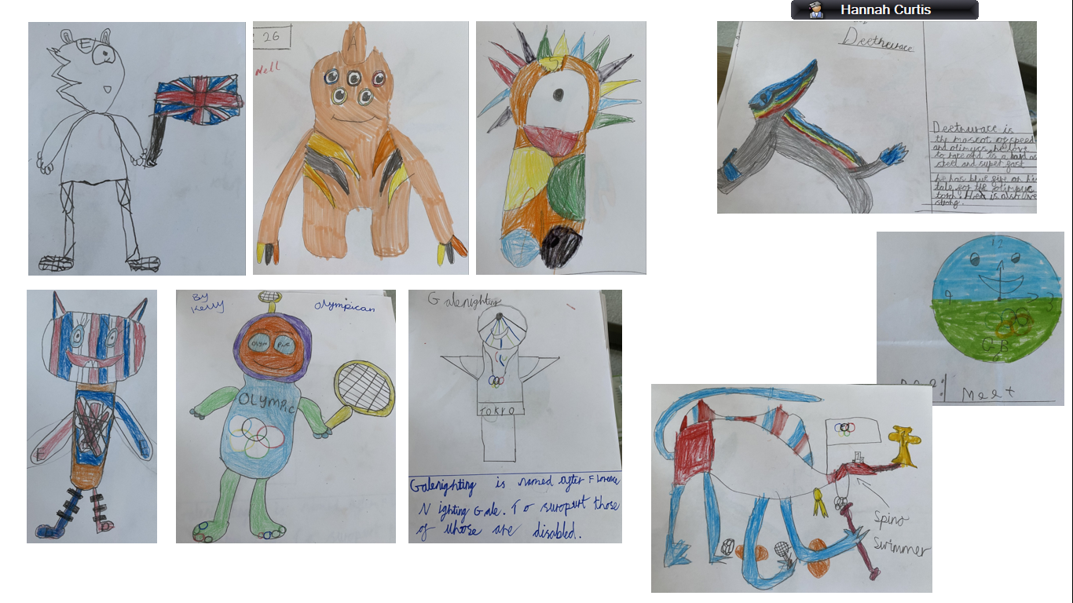
ADVENTURE DAY FOR YEAR 4
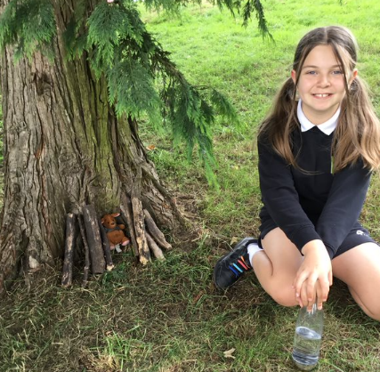
Year 4 enjoyed their adventure day this week. We were lucky enough to have a ranger from Everdon Outdoor Centre come and lead some activities for us in forest school. There were a huge amount of activities but some of our favourites were: wood whittling, shelter building, fire making, toasting (and eating!) marshmallows and woodland art. We also played some team games and consolidated some of our knowledge of predator and prey. We then topped of the day with a BBQ style dinner and a sneaky ice cream! We hope the children enjoyed it as much as we did!
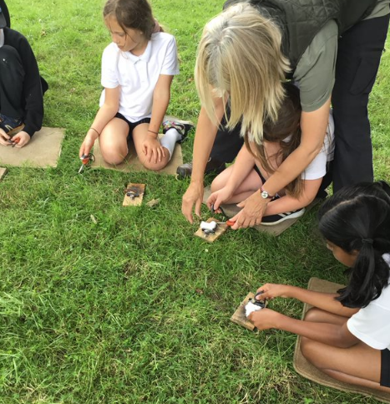
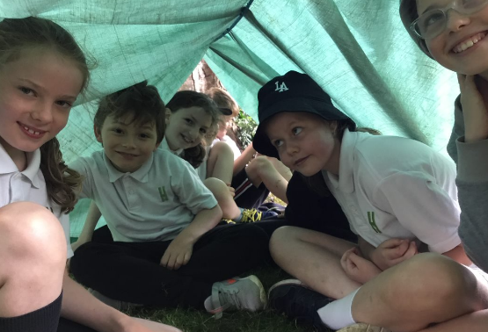

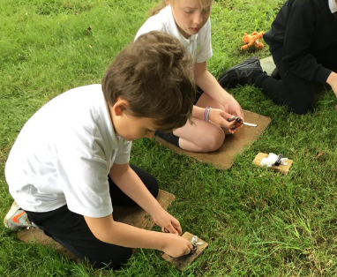
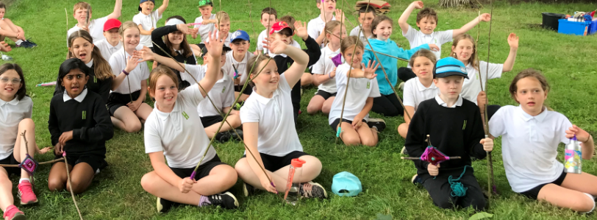

Well done to the following children who have received a certificate this week.
Year Group | Writing | Maths | Reading
Minibeasts | Amber- for working hard with her independent writing. | Isla- for trying hard to recognise her numbers to 10. | Summer- for making so much progress in her fluency.
Tigers | Connie – for working hard in her writing, developing her independent ideas using more exciting vocabulary. | JM – for challenging himself to try all three I cans in one lesson independently! | Rosa – for reading every day to build her expression and comprehension skills with some much longer, more detailed books.
Kangaroos | Ike - for using his phonics to decode words, using adjectives and developing his cursive handwriting. | James F- for developing independence and solving place value problems this week. | Dylan- for developing independence to read comprehension questions and answer them in detail. Transferring this skill to Maths when he had to read his own questions in order to answer place value problems.
Koalas | Jane - for working hard on her handwriting this week | Dylan- for fantastic maths this week where we have been learning to tell the time to the nearest 5 minutes. | Tallulah – for fantastic progress in reading.
Lions | Miles - for showing excellent motivation to write his prequel of the Iron Man. | Kelly - for always showing determination in Maths. | Kieran – for showing fantastic progress in reading and for showing greatly improved confidence.
Otters | Tobias - for his enthusiasm towards our newspaper reports. He even completed another one at home. | Cormac – for our work on written multiplication methods. He has even chosen to do extra practise.
Pandas | Poppy – for writing a fantastic persuasive leaflet and then taking time and care when presenting and illustrating it. | Bertie – for challenging himself and going above and beyond what he first expected.
Brown Bears | Jasmine and Maya for pushing each other on this year, with creative and green exciting writing always shown. | Jenna - for always completing her maths work in a fantastically timely manner along with beautiful presentation.
Polar Bears | Valentin – for really pushing himself in our last big write of Year 5 to create a fabulous suspense-filled story. | Paris – for working hard on her translation work this week. | Victor – for pushing himself to answer all questions in our comprehension this week.
Bumble Bees |  |  | Ruby and Connor - for showing their understanding of Macbeth.
Eagles |  |  | Lyla - for showing their understanding of Macbeth
Also the following children have received a Head Teacher’s award this week:

Minibeasts | Amelie- for being such a positive role model and working hard in all that she does!
Tigers | Jacob – for challenging himself this week, even when he has been unsure in himself.
Kangaroos | Toby- for always trying hard even when things feel difficult. Showing the Heyford Way and being ready to learn.
Koalas | Georgia- for overcoming her fear of performing and showing great confidence
Lions | William T - for spending more time taking part in class activities, and showing a great improvement in showing the Heyford Way.  Tahsin – for making brilliant progress this year!
Otters | Ivy– for incredible attitude on Year 4 Adventure Day. Her enjoyment for every activity was wonderful to see.  Edward - for always showing our school values and trying hard with all of his learning.
Pandas | Win - for the fantastic knowledge she shared during adventure day and for consistently showing our school values. Well done and thank you!
Brown Bears | T All of Brown Bears - for the progress the class has made since the beginning of the year in terms of attitude and commitment has been great to see.
Polar Bears | Ella – for always being a helpful member of the class. We appreciate you!
Bumblebees | Annabel and Liam for their brilliant design of the dragon’s eye of Smorg from the Hobbit.  All of Bumble Bees for their incredible contribution, confidence and creativity in the summer play Dream on!
Eagles | All of Eagles for their incredible contribution, confidence and creativity in the summer play Dream on!
A special shout out to Fyfe who wrote a lovely letter to the Year 6 children after watching their Summer play – this was a really kind gesture and much appreciated by the children and staff – thank you Fyfe.

Also a well done to some of the leadership team who have run a bacon roll sale this morning before school – they have made an incredible £160 so far and still have a cake sale to go! Well done: Lucy, Luke, Charlie and Elsie.

PENTATHLON CHALLENGE

Last Monday Year 3 and 4 took part in a Pentathlon inter-class challenge. The children tried incredibly hard as they participated in 5 athletic events. They showed fabulous determination and support for their teammates. Well done to the event winners and the winning class... Pandas Class!

Standing Long Jump | Vertical Jump | Chest Throw | Speed Bounce | Shuttle Runs
1st – Emily  2nd – Patryk  3rd – Leo | 1st – Melanie  2nd – Maciej  3rd – Lottie | 1st – Ellie  2nd – Lottie  3rd – Toby | 1st – Ellie  2nd – Peter  3rd – Helden | 1st – Cai  2nd – Jacob  3rd – Archie
Year 3 Girls Overall Winners | Year 3 Boys Overall Winners | Year 4 Girls Overall Winners | Year 4 Boys Overall Winners | Overall Winners
1st – Kelly  2nd - Melanie  3rd – Emily | 1st – Helden  2nd – Cai  3rd – Freddie | 1st – Anna  2nd – Ellie  3rd – Poppy | 1st – Archie  2nd – Maciej  3rd – Jacob | 1st – Helden  2nd – Archie  3rd – Maciej  1st -Anna  2nd – Ellie  3rd – Kelly
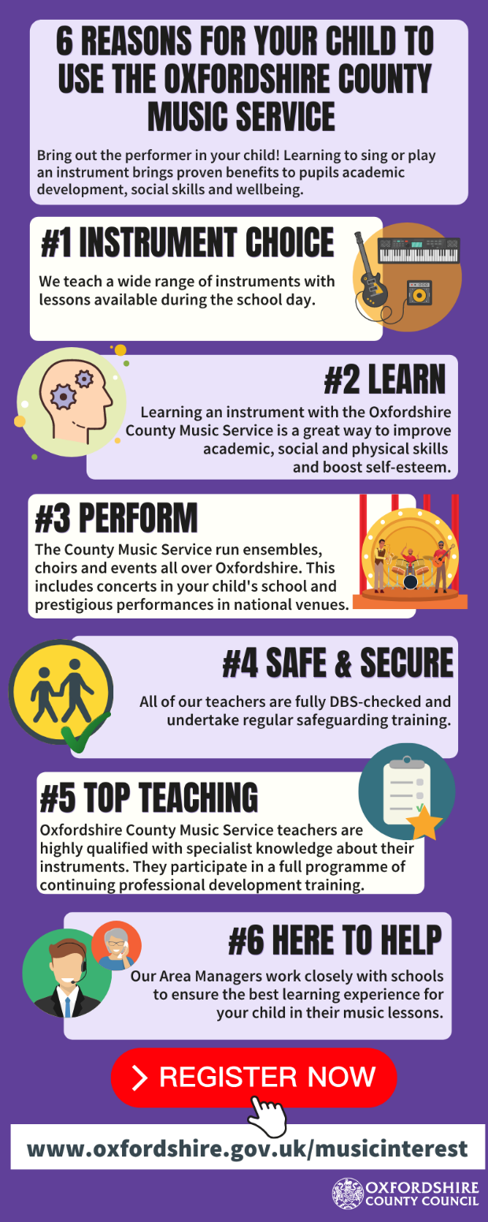
MUSIC LESSONS FOR SEPTEMBER
If your child is interested in learning an instrument there will be opportunities in September to sign up for them – please see advert below for information.
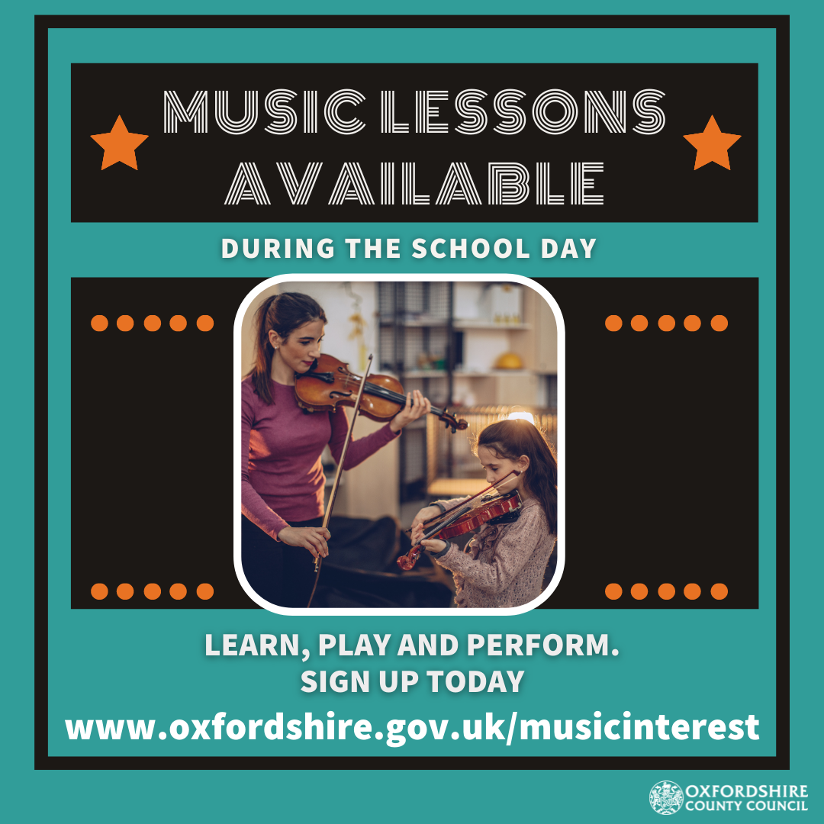

We hope you all have a good weekend.
Year 6 parents please remember you are welcome to join us for the children’s graduation ceremony on Tuesday – 9.30am for Bumble Bees and 11.00am for Eagles.
Best wishes and keep safe
Sarah Nickelson and the Primary Team.

Date | Time | Event | Location
Monday 19th July | All day | Year 6 Celebration Day
Tuesday 20th July | AM | Year 6 Graduation Ceremony  9.30am Bumble Bees  11.00am Eagles | Officers Mess
Wednesday 21st July | 12.15pm | END OF YEAR

